NETWORK LAB — ASSIGNMENT 2
Computer Networks (PCCST501)
Name | Diya Watz
Roll No | 26
Class | S5 CSE-A
Submitted To | Ms. Arsha J K

Experiment 1: TCP Socket Communication — Hello Client/Server
Aim
To design and implement a simple TCP client–server program in C in which the client establishes a connection with the server, transmits a greeting message ("Hello Server"), and the server responds with an acknowledgement ("Hello Client"), thereby illustrating a basic, reliable two-way communication channel using sockets.
Software Used
GCC Compiler, Linux Terminal (WSL / Ubuntu)
Commands Used
● gcc q1_hello_server.c -o q1_hello_server
● gcc q1_hello_client.c -o q1_hello_client
● ./q1_hello_server (Terminal 1)
● ./q1_hello_client (Terminal 2)
Algorithm
Server:
1. Create a TCP socket using socket().
2. Bind the socket to INADDR_ANY on port 8081 using bind().
3. Put the socket into listening mode using listen().
4. Accept an incoming client request using accept().
5. Read the message sent by the client using recv().
6. Display the received message and send back "Hello Client" using send().
7. Close the client and server sockets.
Client:
1. Create a TCP socket using socket().
2. Set the target server IP (127.0.0.1) and port (8081).
3. Establish a connection to the server using connect().
4. Transmit the message "Hello Server" using send().
5. Wait for and display the server's reply using recv().
6. Close the socket.
Server Code
q1_hello_server.c
#include <stdio.h>
#include <stdlib.h>
#include <string.h>
#include <unistd.h>
#include <arpa/inet.h>
#include <sys/socket.h>

#define PORT 8081
#define BUFFER_SIZE 1024

int main() {
int server_fd, client_fd;
struct sockaddr_in server_addr, client_addr;
socklen_t client_len = sizeof(client_addr);
char buffer[BUFFER_SIZE] = {0};
const char *reply = "Hello Client";

server_fd = socket(AF_INET, SOCK_STREAM, 0);
if (server_fd < 0) {
perror("socket failed");
exit(EXIT_FAILURE);
}
printf("Socket Created Successfully...\n");

int opt = 1;
setsockopt(server_fd, SOL_SOCKET, SO_REUSEADDR, &opt, sizeof(opt));

server_addr.sin_family = AF_INET;
server_addr.sin_addr.s_addr = INADDR_ANY;
server_addr.sin_port = htons(PORT);

if (bind(server_fd, (struct sockaddr *)&server_addr, sizeof(server_addr)) < 0) {
perror("bind failed");
close(server_fd);
exit(EXIT_FAILURE);
}
printf("Bind Successful...\n");

if (listen(server_fd, 3) < 0) {
perror("listen failed");
close(server_fd);
exit(EXIT_FAILURE);
}
printf("Waiting for Client...\n");

client_fd = accept(server_fd, (struct sockaddr *)&client_addr, &client_len);
if (client_fd < 0) {
perror("accept failed");
close(server_fd);
exit(EXIT_FAILURE);
}
printf("Client Connected...\n");

ssize_t bytes_received = recv(client_fd, buffer, BUFFER_SIZE - 1, 0);
if (bytes_received > 0) {
buffer[bytes_received] = '\0';
printf("Client Says : %s\n", buffer);
}

send(client_fd, reply, strlen(reply), 0);
printf("Reply Sent...\n");

close(client_fd);
close(server_fd);
printf("Connection Closed...\n");
return 0;
}

Client Code
q1_hello_client.c
#include <stdio.h>
#include <stdlib.h>
#include <string.h>
#include <unistd.h>
#include <arpa/inet.h>
#include <sys/socket.h>

#define PORT 8081
#define BUFFER_SIZE 1024
#define SERVER_IP "127.0.0.1"

int main() {
int client_fd;
struct sockaddr_in server_addr;
char buffer[BUFFER_SIZE] = {0};
const char *message = "Hello Server";

client_fd = socket(AF_INET, SOCK_STREAM, 0);
if (client_fd < 0) {
perror("socket failed");
exit(EXIT_FAILURE);
}
printf("Socket Created Successfully...\n");

server_addr.sin_family = AF_INET;
server_addr.sin_port = htons(PORT);

if (inet_pton(AF_INET, SERVER_IP, &server_addr.sin_addr) <= 0) {
perror("invalid address");
close(client_fd);
exit(EXIT_FAILURE);
}

if (connect(client_fd, (struct sockaddr *)&server_addr, sizeof(server_addr)) < 0) {
perror("connect failed");
close(client_fd);
exit(EXIT_FAILURE);
}
printf("Connected to Server...\n");

send(client_fd, message, strlen(message), 0);
printf("Message Sent : %s\n", message);

ssize_t bytes_received = recv(client_fd, buffer, BUFFER_SIZE - 1, 0);
if (bytes_received > 0) {
buffer[bytes_received] = '\0';
printf("Reply from Server : %s\n", buffer);
}

close(client_fd);
printf("Connection Closed...\n");
return 0;
}

Output
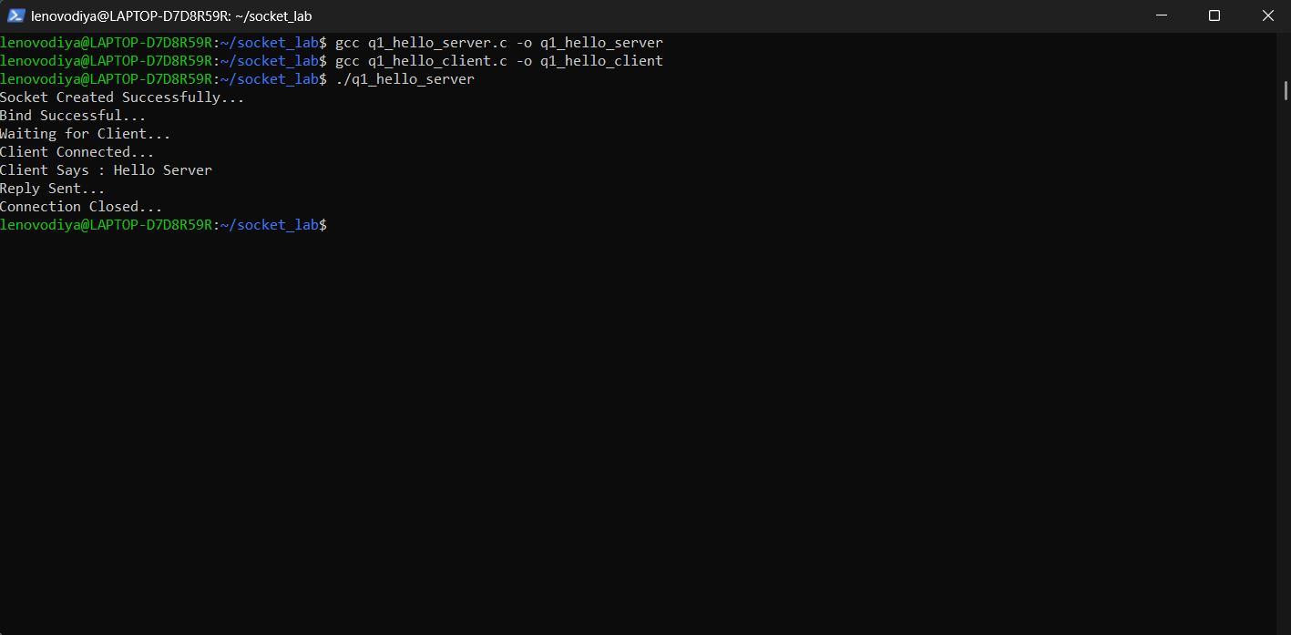
Fig 1.1: Server Terminal
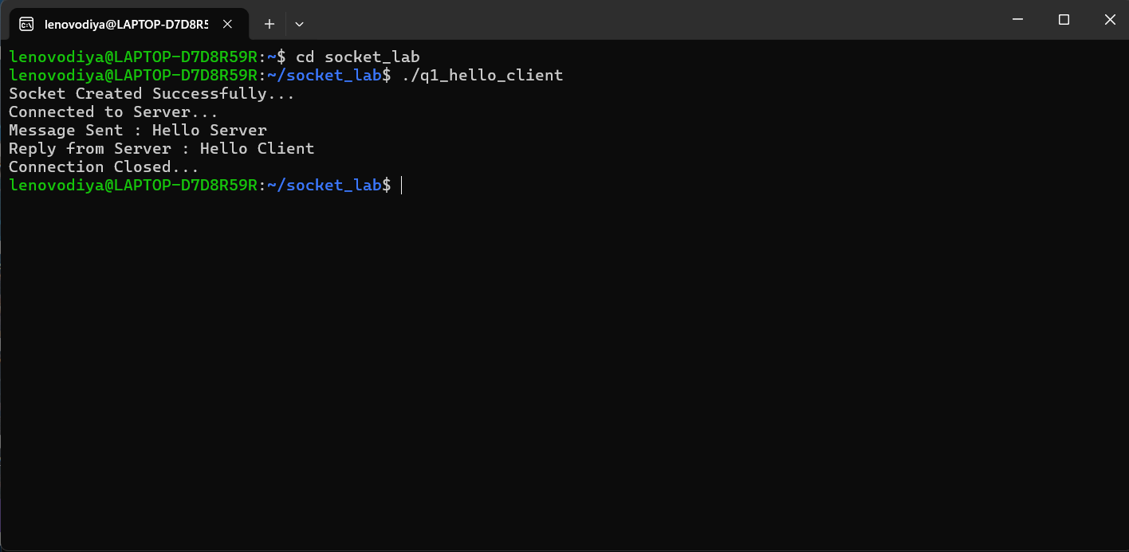
Fig 1.2: Client Terminal
Conclusion
The TCP client–server communication program executed exactly as expected. Once the server began listening, the client connected successfully, sent the message "Hello Server", and received "Hello Client" in response — verifying that a dependable, connection-oriented communication link was established between the two processes.

Experiment 2: Arithmetic Server
Aim
To design a client–server system in which the client transmits two integers to the server, which then calculates and returns their sum, difference, product, and quotient — illustrating numeric data exchange and remote computation through TCP sockets.
Software Used
GCC Compiler, Linux Terminal (WSL / Ubuntu)
Commands Used
● gcc q2_arithmetic_server.c -o q2_arithmetic_server
● gcc q2_arithmetic_client.c -o q2_arithmetic_client
● ./q2_arithmetic_server (Terminal 1)
● ./q2_arithmetic_client (Terminal 2)
Algorithm
Server:
1. Create a TCP socket and enable SO_REUSEADDR using setsockopt().
2. Bind the socket to INADDR_ANY on port 8082 using bind().
3. Put the socket into listening mode using listen().
4. Accept an incoming client connection using accept().
5. Receive the two space-separated integers using recv().
6. Parse the values with sscanf() and compute the sum, difference, product, and quotient (guarding against division by zero).
7. Format the results into a string and send them back using send().
8. Close the client and server sockets.
Client:
1. Create a TCP socket using socket().
2. Set the target server IP (127.0.0.1) and port (8082).
3. Connect to the server using connect().
4. Prompt the user for two integers and build a message string from them.
5. Send the message to the server using send().
6. Receive and display the computed results using recv().
7. Close the socket.
Server Code
q2_arithmetic_server.c
#include <stdio.h>
#include <stdlib.h>
#include <string.h>
#include <unistd.h>
#include <arpa/inet.h>
#include <sys/socket.h>

#define PORT 8082
#define BUFFER_SIZE 1024

int main() {
int server_fd, client_fd;
struct sockaddr_in server_addr, client_addr;
socklen_t client_len = sizeof(client_addr);
char buffer[BUFFER_SIZE] = {0};
char result[BUFFER_SIZE] = {0};

server_fd = socket(AF_INET, SOCK_STREAM, 0);
int opt = 1;
setsockopt(server_fd, SOL_SOCKET, SO_REUSEADDR, &opt, sizeof(opt));

server_addr.sin_family = AF_INET;
server_addr.sin_addr.s_addr = INADDR_ANY;
server_addr.sin_port = htons(PORT);

bind(server_fd, (struct sockaddr *)&server_addr, sizeof(server_addr));
listen(server_fd, 3);
printf("Arithmetic Server listening on port %d...\n", PORT);

client_fd = accept(server_fd, (struct sockaddr *)&client_addr, &client_len);
printf("Client Connected...\n");

int n = recv(client_fd, buffer, BUFFER_SIZE - 1, 0);
buffer[n] = '\0';

int a, b;
sscanf(buffer, "%d %d", &a, &b);
printf("Received numbers: %d and %d\n", a, b);

int sum = a + b;
int diff = a - b;
int prod = a * b;

if (b != 0) {
double quo = (double)a / b;
snprintf(result, BUFFER_SIZE,
"Addition : %d\nSubtraction : %d\nMultiplication : %d\nDivision : %.2f",
sum, diff, prod, quo);
} else {
snprintf(result, BUFFER_SIZE,
"Addition : %d\nSubtraction : %d\nMultiplication : %d\nDivision : Undefined (division by zero)",
sum, diff, prod);
}

send(client_fd, result, strlen(result), 0);
printf("Results sent to client.\n");

close(client_fd);
close(server_fd);
return 0;
}

Client Code
q2_arithmetic_client.c
#include <stdio.h>
#include <stdlib.h>
#include <string.h>
#include <unistd.h>
#include <arpa/inet.h>
#include <sys/socket.h>

#define PORT 8082
#define BUFFER_SIZE 1024
#define SERVER_IP "127.0.0.1"

int main() {
int client_fd;
struct sockaddr_in server_addr;
char buffer[BUFFER_SIZE] = {0};
char message[BUFFER_SIZE] = {0};
int a, b;

client_fd = socket(AF_INET, SOCK_STREAM, 0);
server_addr.sin_family = AF_INET;
server_addr.sin_port = htons(PORT);
inet_pton(AF_INET, SERVER_IP, &server_addr.sin_addr);

connect(client_fd, (struct sockaddr *)&server_addr, sizeof(server_addr));
printf("Connected to Server...\n");

printf("Enter first integer : ");
scanf("%d", &a);
printf("Enter second integer : ");
scanf("%d", &b);

snprintf(message, BUFFER_SIZE, "%d %d", a, b);
send(client_fd, message, strlen(message), 0);
printf("Numbers sent to server...\n");

int n = recv(client_fd, buffer, BUFFER_SIZE - 1, 0);
buffer[n] = '\0';
printf("\nResults from Server:\n%s\n", buffer);

close(client_fd);
return 0;
}

Output
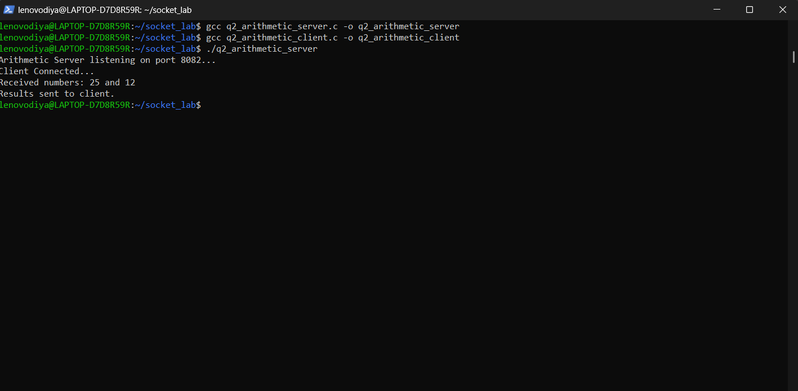
Fig 2.1: Server Terminal
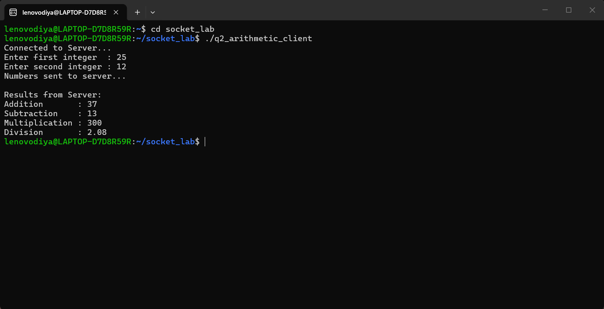
Fig 2.2: Client Terminal
Conclusion
Testing the arithmetic server with the inputs 25 and 12 produced the correct outputs — Addition = 37, Subtraction = 13, Multiplication = 300, and Division = 2.08 — all returned to the client over the socket connection. This confirms accurate numeric computation and reliable data exchange between the two processes.

Experiment 3: String Processing Server
Aim
To build a client–server application in which the client forwards a text string to the server, and the server determines its length, converts it to uppercase, and reverses it before sending all three results back to the client, demonstrating string handling over a socket connection.
Software Used
GCC Compiler, Linux Terminal (WSL / Ubuntu)
Commands Used
● gcc q3_string_server.c -o q3_string_server
● gcc q3_string_client.c -o q3_string_client
● ./q3_string_server (Terminal 1)
● ./q3_string_client (Terminal 2)
Algorithm
Server:
1. Create a TCP socket and enable SO_REUSEADDR using setsockopt().
2. Bind the socket to INADDR_ANY on port 8083 using bind().
3. Put the socket into listening mode using listen().
4. Accept an incoming client connection using accept().
5. Receive the string sent by the client using recv().
6. Compute the length, convert it to uppercase, and reverse it.
7. Format all three results into a single string and send them using send().
8. Close the client and server sockets.
Client:
1. Create a TCP socket using socket().
2. Set the target server IP (127.0.0.1) and port (8083).
3. Connect to the server using connect().
4. Read a string from the user with fgets() and strip the trailing newline.
5. Send the string to the server using send().
6. Receive and display the processed results using recv().
7. Close the socket.
Server Code
q3_string_server.c
#include <stdio.h>
#include <stdlib.h>
#include <string.h>
#include <ctype.h>
#include <unistd.h>
#include <arpa/inet.h>
#include <sys/socket.h>

#define PORT 8083
#define BUFFER_SIZE 1024

int main() {
int server_fd, client_fd;
struct sockaddr_in server_addr, client_addr;
socklen_t client_len = sizeof(client_addr);
char buffer[BUFFER_SIZE] = {0};
char upper[BUFFER_SIZE] = {0};
char reversed[BUFFER_SIZE] = {0};
char result[BUFFER_SIZE * 3] = {0};

server_fd = socket(AF_INET, SOCK_STREAM, 0);
int opt = 1;
setsockopt(server_fd, SOL_SOCKET, SO_REUSEADDR, &opt, sizeof(opt));

server_addr.sin_family = AF_INET;
server_addr.sin_addr.s_addr = INADDR_ANY;
server_addr.sin_port = htons(PORT);

bind(server_fd, (struct sockaddr *)&server_addr, sizeof(server_addr));
listen(server_fd, 3);
printf("String Processing Server listening on port %d...\n", PORT);

client_fd = accept(server_fd, (struct sockaddr *)&client_addr, &client_len);
printf("Client Connected...\n");

int n = recv(client_fd, buffer, BUFFER_SIZE - 1, 0);
buffer[n] = '\0';
printf("Received string: %s\n", buffer);

int len = strlen(buffer);
for (int i = 0; i < len; i++)
upper[i] = toupper(buffer[i]);
upper[len] = '\0';

for (int i = 0; i < len; i++)
reversed[i] = buffer[len - 1 - i];
reversed[len] = '\0';

snprintf(result, sizeof(result),
"Length : %d\nUppercase : %s\nReversed : %s",
len, upper, reversed);

send(client_fd, result, strlen(result), 0);
printf("Results sent to client.\n");

close(client_fd);
close(server_fd);
return 0;
}

Client Code
q3_string_client.c
#include <stdio.h>
#include <stdlib.h>
#include <string.h>
#include <unistd.h>
#include <arpa/inet.h>
#include <sys/socket.h>

#define PORT 8083
#define BUFFER_SIZE 1024
#define SERVER_IP "127.0.0.1"

int main() {
int client_fd;
struct sockaddr_in server_addr;
char buffer[BUFFER_SIZE] = {0};
char input[BUFFER_SIZE];

client_fd = socket(AF_INET, SOCK_STREAM, 0);
server_addr.sin_family = AF_INET;
server_addr.sin_port = htons(PORT);
inet_pton(AF_INET, SERVER_IP, &server_addr.sin_addr);

connect(client_fd, (struct sockaddr *)&server_addr, sizeof(server_addr));
printf("Connected to Server...\n");

printf("Enter a string: ");
fgets(input, BUFFER_SIZE, stdin);
input[strcspn(input, "\n")] = '\0';

send(client_fd, input, strlen(input), 0);
printf("String sent to server...\n");

int n = recv(client_fd, buffer, BUFFER_SIZE - 1, 0);
buffer[n] = '\0';
printf("\nResults from Server:\n%s\n", buffer);

close(client_fd);
return 0;
}

Output
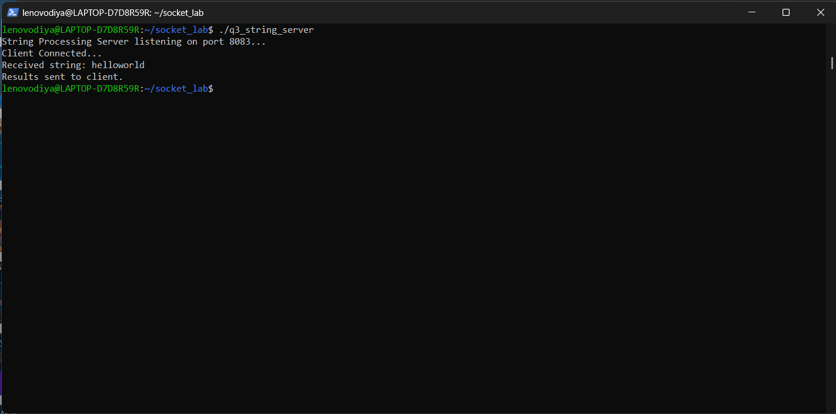
Fig 3.1: Server Terminal
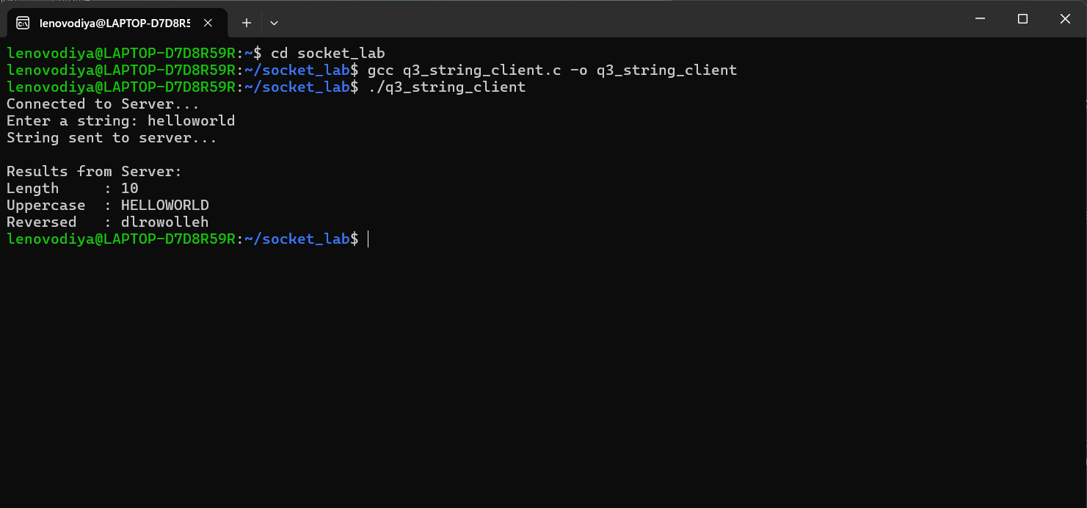
Fig 3.2: Client Terminal
Conclusion
Running the string processing server with the input "helloworld" produced Length = 10, Uppercase = HELLOWORLD, and Reversed = dlrowolleh, all correctly returned to the client. This verifies that the string operations were carried out accurately across the socket connection.

Experiment 4: Array Processing Server
Aim
To develop a client–server application in which the client sends an array of N integers to the server, which then calculates the sum, average, maximum, and minimum of the elements — showcasing array transfer and aggregate computation via TCP sockets.
Software Used
GCC Compiler, Linux Terminal (WSL / Ubuntu)
Commands Used
● gcc q4_array_server.c -o q4_array_server
● gcc q4_array_client.c -o q4_array_client
● ./q4_array_server (Terminal 1)
● ./q4_array_client (Terminal 2)
Algorithm
Server:
1. Create a TCP socket and enable SO_REUSEADDR using setsockopt().
2. Bind the socket to INADDR_ANY on port 8084 using bind().
3. Put the socket into listening mode using listen().
4. Accept an incoming client connection using accept().
5. Receive the message containing N followed by N integers using recv().
6. Tokenize the message with strtok() to extract N and the array elements.
7. Compute the sum, average, maximum, and minimum of the elements.
8. Format the results and send them back using send().
9. Close the client and server sockets.
Client:
1. Create a TCP socket using socket().
2. Set the target server IP (127.0.0.1) and port (8084).
3. Connect to the server using connect().
4. Read the count N and then N integers from the user.
5. Build a single message string containing N followed by the array elements.
6. Send the message to the server using send().
7. Receive and display the computed results using recv().
8. Close the socket.
Server Code
q4_array_server.c
#include <stdio.h>
#include <stdlib.h>
#include <string.h>
#include <unistd.h>
#include <arpa/inet.h>
#include <sys/socket.h>

#define PORT 8084
#define BUFFER_SIZE 1024

int main() {
int server_fd, client_fd;
struct sockaddr_in server_addr, client_addr;
socklen_t client_len = sizeof(client_addr);
char buffer[BUFFER_SIZE] = {0};
char result[BUFFER_SIZE] = {0};

server_fd = socket(AF_INET, SOCK_STREAM, 0);
int opt = 1;
setsockopt(server_fd, SOL_SOCKET, SO_REUSEADDR, &opt, sizeof(opt));

server_addr.sin_family = AF_INET;
server_addr.sin_addr.s_addr = INADDR_ANY;
server_addr.sin_port = htons(PORT);

bind(server_fd, (struct sockaddr *)&server_addr, sizeof(server_addr));
listen(server_fd, 3);
printf("Array Processing Server listening on port %d...\n", PORT);

client_fd = accept(server_fd, (struct sockaddr *)&client_addr, &client_len);
printf("Client Connected...\n");

int n = recv(client_fd, buffer, BUFFER_SIZE - 1, 0);
buffer[n] = '\0';

int arr[100], count = 0;
char *token = strtok(buffer, " ");
int N = atoi(token);
printf("Received %d integers.\n", N);

token = strtok(NULL, " ");
while (token != NULL && count < N) {
arr[count++] = atoi(token);
token = strtok(NULL, " ");
}

int sum = 0, max = arr[0], min = arr[0];
for (int i = 0; i < count; i++) {
sum += arr[i];
if (arr[i] > max) max = arr[i];
if (arr[i] < min) min = arr[i];
}
double avg = (double)sum / count;

snprintf(result, BUFFER_SIZE,
"Sum : %d\nAverage : %.2f\nMaximum : %d\nMinimum : %d",
sum, avg, max, min);

send(client_fd, result, strlen(result), 0);
printf("Results sent to client.\n");

close(client_fd);
close(server_fd);
return 0;
}

Client Code
q4_array_client.c
#include <stdio.h>
#include <stdlib.h>
#include <string.h>
#include <unistd.h>
#include <arpa/inet.h>
#include <sys/socket.h>

#define PORT 8084
#define BUFFER_SIZE 1024
#define SERVER_IP "127.0.0.1"

int main() {
int client_fd;
struct sockaddr_in server_addr;
char buffer[BUFFER_SIZE] = {0};
char message[BUFFER_SIZE] = {0};
int arr[100], N;

client_fd = socket(AF_INET, SOCK_STREAM, 0);
server_addr.sin_family = AF_INET;
server_addr.sin_port = htons(PORT);
inet_pton(AF_INET, SERVER_IP, &server_addr.sin_addr);

connect(client_fd, (struct sockaddr *)&server_addr, sizeof(server_addr));
printf("Connected to Server...\n");

printf("Enter number of elements (N): ");
scanf("%d", &N);
printf("Enter %d integers: ", N);

char temp[16];
snprintf(message, BUFFER_SIZE, "%d", N);
for (int i = 0; i < N; i++) {
scanf("%d", &arr[i]);
snprintf(temp, sizeof(temp), " %d", arr[i]);
strcat(message, temp);
}

send(client_fd, message, strlen(message), 0);
printf("\nArray sent to server...\n");

int n = recv(client_fd, buffer, BUFFER_SIZE - 1, 0);
buffer[n] = '\0';
printf("\nResults from Server:\n%s\n", buffer);

close(client_fd);
return 0;
}

Output
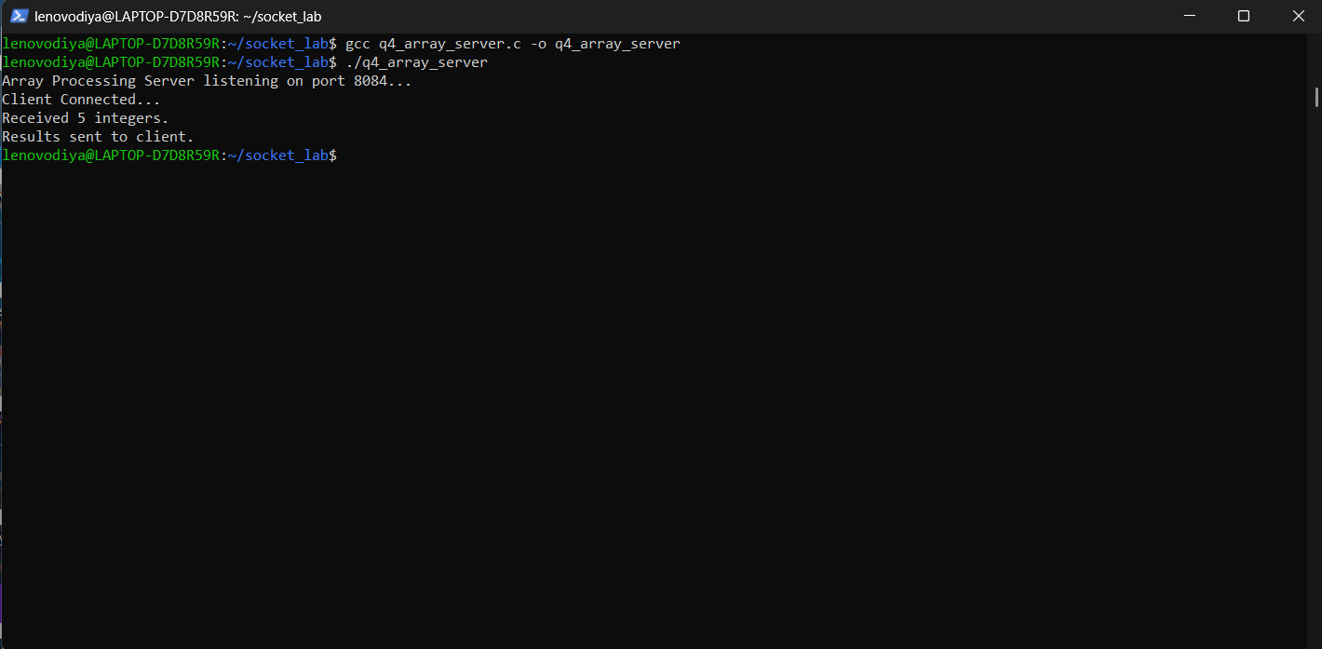
Fig 4.1: Server Terminal
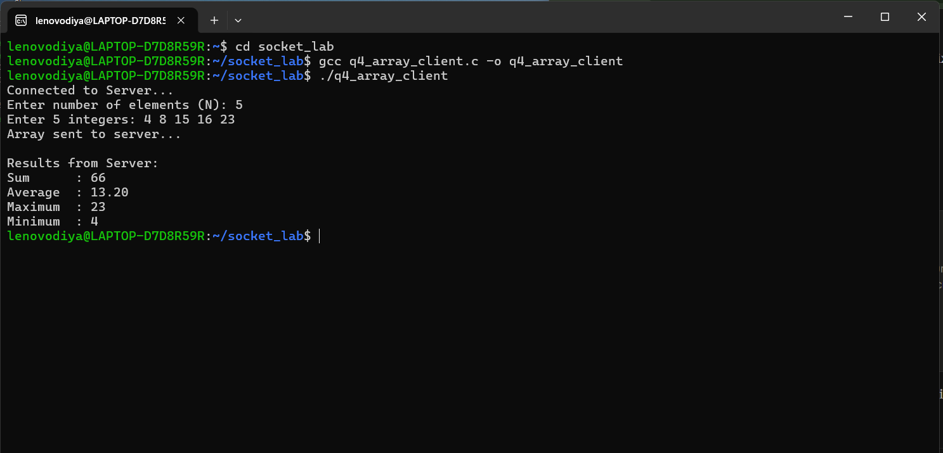
Fig 4.2: Client Terminal
Conclusion
With the array {4, 8, 15, 16, 23} supplied as input, the server correctly returned Sum = 66, Average = 13.20, Maximum = 23, and Minimum = 4. This confirms that array data was transmitted and processed accurately across the client–server model.

Experiment 5: Matrix Analyzer
Aim
To create a client–server program in which the client sends a square matrix to the server, which identifies whether it is diagonal, upper triangular, lower triangular, or general, and also computes the sum of its elements and its trace — demonstrating two-dimensional array handling over TCP sockets.
Software Used
GCC Compiler, Linux Terminal (WSL / Ubuntu)
Commands Used
● gcc q5_matrix_server.c -o q5_matrix_server
● gcc q5_matrix_client.c -o q5_matrix_client
● ./q5_matrix_server (Terminal 1)
● ./q5_matrix_client (Terminal 2)
Algorithm
Server:
1. Create a TCP socket and enable SO_REUSEADDR using setsockopt().
2. Bind the socket to INADDR_ANY on port 8085 using bind().
3. Put the socket into listening mode using listen().
4. Accept an incoming client connection using accept().
5. Receive the message containing N followed by the N×N matrix elements using recv().
6. Tokenize the message with strtok() to reconstruct N and the matrix.
7. Check the matrix for diagonal, upper triangular, and lower triangular properties and classify it accordingly.
8. Compute the sum of all elements and the trace (sum of the diagonal elements).
9. Format the matrix type, sum, and trace into a string and send them using send().
10. Close the client and server sockets.
Client:
1. Create a TCP socket using socket().
2. Set the target server IP (127.0.0.1) and port (8085).
3. Connect to the server using connect().
4. Read the order N and then the N×N matrix elements from the user.
5. Display the entered matrix locally for confirmation.
6. Build a single message string containing N followed by all the matrix elements.
7. Send the message to the server using send().
8. Receive and display the computed results (matrix type, sum, trace) using recv().
9. Close the socket.
Server Code
q5_matrix_server.c
#include <stdio.h>
#include <stdlib.h>
#include <string.h>
#include <unistd.h>
#include <arpa/inet.h>
#include <sys/socket.h>

#define PORT 8085
#define BUFFER_SIZE 4096
#define MAXN 20

int main() {
int server_fd, client_fd;
struct sockaddr_in server_addr, client_addr;
socklen_t client_len = sizeof(client_addr);
char buffer[BUFFER_SIZE] = {0};
char result[BUFFER_SIZE] = {0};
int mat[MAXN][MAXN];

server_fd = socket(AF_INET, SOCK_STREAM, 0);
int opt = 1;
setsockopt(server_fd, SOL_SOCKET, SO_REUSEADDR, &opt, sizeof(opt));

server_addr.sin_family = AF_INET;
server_addr.sin_addr.s_addr = INADDR_ANY;
server_addr.sin_port = htons(PORT);

bind(server_fd, (struct sockaddr *)&server_addr, sizeof(server_addr));
listen(server_fd, 3);
printf("Matrix Analyzer Server listening on port %d...\n", PORT);

client_fd = accept(server_fd, (struct sockaddr *)&client_addr, &client_len);
printf("Client Connected...\n");

int n = recv(client_fd, buffer, BUFFER_SIZE - 1, 0);
buffer[n] = '\0';

char *token = strtok(buffer, " ");
int N = atoi(token);
printf("Received %dx%d matrix.\n", N, N);

for (int i = 0; i < N; i++) {
for (int j = 0; j < N; j++) {
token = strtok(NULL, " ");
mat[i][j] = atoi(token);
}
}

int isDiagonal = 1, isUpper = 1, isLower = 1;
for (int i = 0; i < N; i++) {
for (int j = 0; j < N; j++) {
if (i != j && mat[i][j] != 0) isDiagonal = 0;
if (i > j && mat[i][j] != 0) isUpper = 0;
if (i < j && mat[i][j] != 0) isLower = 0;
}
}

char type[32];
if (isDiagonal)
strcpy(type, "Diagonal Matrix");
else if (isUpper)
strcpy(type, "Upper Triangular Matrix");
else if (isLower)
strcpy(type, "Lower Triangular Matrix");
else
strcpy(type, "General Matrix");

int sum = 0, trace = 0;
for (int i = 0; i < N; i++) {
for (int j = 0; j < N; j++) {
sum += mat[i][j];
}
trace += mat[i][i];
}

snprintf(result, BUFFER_SIZE,
"Matrix Type : %s\nSum of Elements : %d\nTrace : %d",
type, sum, trace);

send(client_fd, result, strlen(result), 0);
printf("Results sent to client.\n");

close(client_fd);
close(server_fd);
return 0;
}

Client Code
q5_matrix_client.c
#include <stdio.h>
#include <stdlib.h>
#include <string.h>
#include <unistd.h>
#include <arpa/inet.h>
#include <sys/socket.h>

#define PORT 8085
#define BUFFER_SIZE 4096
#define SERVER_IP "127.0.0.1"
#define MAXN 20

int main() {
int client_fd;
struct sockaddr_in server_addr;
char buffer[BUFFER_SIZE] = {0};
char message[BUFFER_SIZE] = {0};
int mat[MAXN][MAXN], N;

client_fd = socket(AF_INET, SOCK_STREAM, 0);
server_addr.sin_family = AF_INET;
server_addr.sin_port = htons(PORT);
inet_pton(AF_INET, SERVER_IP, &server_addr.sin_addr);

connect(client_fd, (struct sockaddr *)&server_addr, sizeof(server_addr));
printf("Connected to Server...\n");

printf("Enter matrix order N: ");
scanf("%d", &N);
printf("Enter %d matrix elements (row by row):\n", N * N);

char temp[16];
snprintf(message, BUFFER_SIZE, "%d", N);
for (int i = 0; i < N; i++) {
for (int j = 0; j < N; j++) {
scanf("%d", &mat[i][j]);
snprintf(temp, sizeof(temp), " %d", mat[i][j]);
strcat(message, temp);
}
}

printf("\nEntered Matrix:\n");
for (int i = 0; i < N; i++) {
for (int j = 0; j < N; j++)
printf("%d ", mat[i][j]);
printf("\n");
}

send(client_fd, message, strlen(message), 0);
printf("\nMatrix sent to server...\n");

int n = recv(client_fd, buffer, BUFFER_SIZE - 1, 0);
buffer[n] = '\0';
printf("\nServer Response:\n%s\n", buffer);

close(client_fd);
return 0;
}

Output
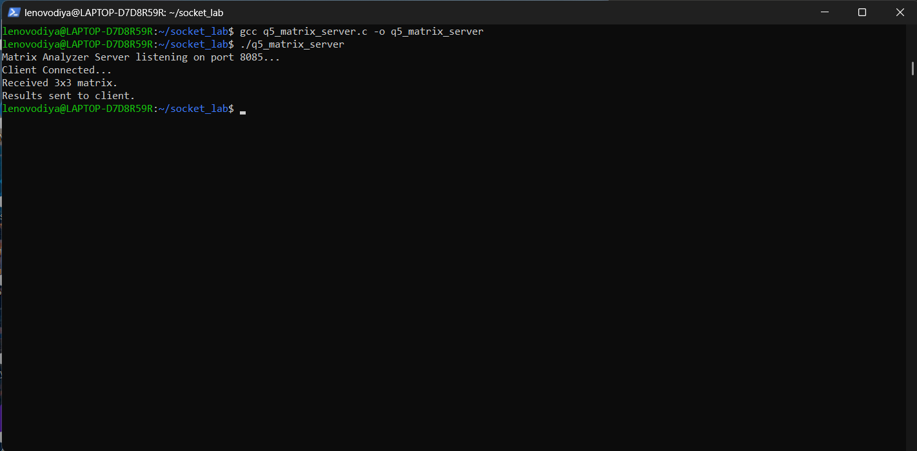
Fig 5.1: Server Terminal
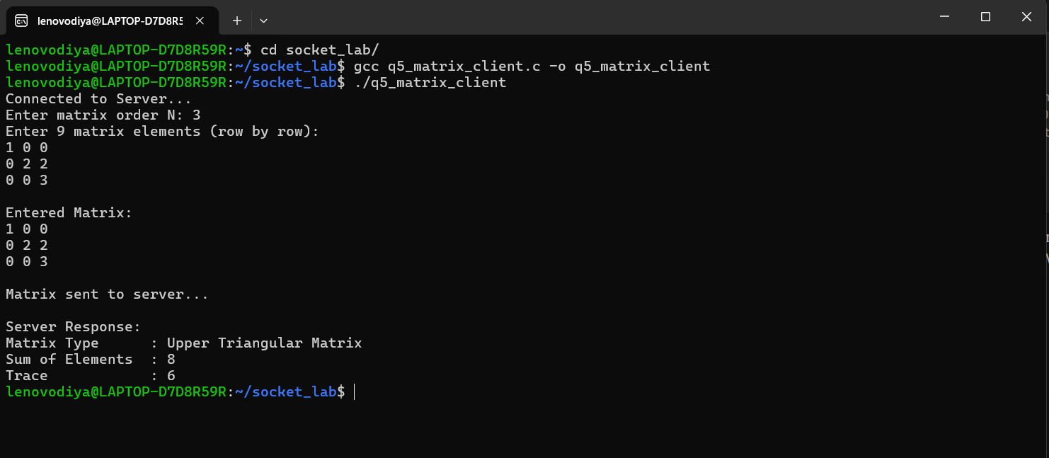
Fig 5.2: Client Terminal
Conclusion
Testing with the 3×3 matrix {{1,0,0},{0,2,2},{0,0,3}} confirmed the server's classification logic — it correctly identified the matrix as an Upper Triangular Matrix, with Sum of Elements = 8 and Trace = 6. This validates accurate two-dimensional array processing across the socket connection.

